Special Edition Communications Alert: How to spot Employee Retention Credit scams
IRS colleagues and partners,
Please help spread this important message about the Employee Retention Credit (ERC) and the continually evolving scams related to the credit. The ERC, sometimes also called the Employee Retention Tax Credit or ERTC, is a valuable credit for businesses and tax-exempt organizations that qualified for this pandemic-related credit in 2020 and 2021.
Claiming the ERC improperly could result in someone having to repay the credit, along with potential penalties and interest. We don’t want this to happen to taxpayers!
Recently, the IRS shared information on the warning signs of aggressive ERC marketing and details on how promoters lure victims. You can help employers protect themselves by sharing IRS materials about ERC scams. Thank you for your partnership!
News releases:
- NEW: IRS alerts businesses, tax-exempt groups of warning signs for misleading Employee Retention scams; simple steps can avoid improperly filing claims English, Spanish & Chinese
- Employee Retention Credit: Beware of too-good-to-be-true offers English, Spanish & Chinese
e-Poster/flier to share electronically or post in your office or community:
- Publication 5792, Small Businesses & Tax-Exempt Organizations: Beware of Tax Credit Scams! English & Spanish
ERC videos on YouTube you can share on your social media platforms or in other content:
- Don’t Fall for Employee Retention Credit Scams English & Spanish
ERC video shorts on YouTube with captions (multilingual) you can share on your social media platforms or in other content:
- Avoid schemes promoting the Employee Retention Credit English & Spanish
- Beware of adds that promise big money by claiming the Employee Retention Credit. (Note: this caption in English is for reference only) Two video shorts in 6 languages:
  - Spanish video #1 & video #2
Cuidado con los anuncios que prometen mucho dinero a través del crédito por retención de empleados. www.irs.gov/erc
  - Chinese video #1 & video #2
请当心不实广告. 尤其是有关员工续雇税务优惠. 查询详情，www.irs.gov/erc
  - Haitian-Creole video #1 & video #2
Pran prekosyon nou ak anons ki pwomèt gwo lajan Atravè kredi taks pou kenbe anplwaye a. www.irs.gov/erc
  - Korean video #1 & video #2
직원 유지 세액 공제를 통해서 큰돈을 받게해준다는 광고를 조심하십시오. www.irs.gov/erc
  - Russian video #1 & video #2
Остерегайтесь рекламы, обещающей большие деньги за счет налогового кредита на удержание сотрудников. www.irs.gov/erc
  - Vietnamese video #1 & video #2
Cẩn thận với những quảng cáo hứa hẹn số tiền lớn thông qua tín thuế duy trì nhân viên. www.irs.gov/erc
IRS Tax Tip for newsletters, emails or web content:
- Employers: Watch out for Employee Retention Credit scheme English & Spanish
Ready-to-use article for newsletters, emails or web content:
- Beware of Employee Retention Credit scammers
IRS Public Service Announcements (PSAs) for radio:
- Employee Retention Credit Scam, 15 sec. English, Spanish & Chinese
  - Text transcript English, Spanish & Chinese
- Employee Retention Credit Scam, 30 sec. English, Spanish & Chinese
  - Text transcript English, Spanish & Chinese
Social media messages:
Employee Retention Credit scams alert:

- #IRS alerts businesses and tax-exempt groups of the warning signs for misleading Employee Retention scams. Follow these simple steps to avoid improperly filing claims: http://ow.ly/JHTA50Ox0hx #ERC #ERTC

- Business owners: Learn the signs and steps to avoid improperly filing claims involving misleading Employee Retention Credit scams. http://ow.ly/JHTA50Ox0hx. #ERC #ERTC

- #IRS and #TaxPros continue to see a high volume of aggressive broadcast advertising, direct mail solicitations and online promotions involving the Employee Retention Credit. Find out more: http://ow.ly/JHTA50Ox0hx #ERC #ERTC

- #IRS warns of wildly misleading claims and scams regarding the Employee Retention Credit. “The aggressive marketing of the #ERC continues preying on innocent businesses and others," said IRS Commissioner Danny Werfel. Read more: http://ow.ly/JHTA50Ox0hx #ERTC

- Help #IRS spread the word about misleading Employee Retention Credit scams aimed at businesses and tax-exempt groups. Learn more: http://ow.ly/JHTA50Ox0hx #ERC #ERTC

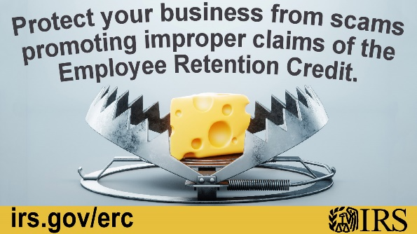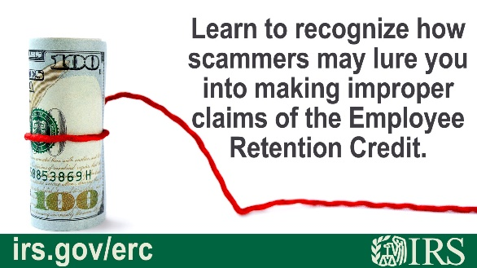


Employee Retention Credit beware:
English:
- You’ve probably seen those pushy ads encouraging businesses and others to claim the Employee Retention Credit. Don’t fall for ERC or ERTC offers beyond the #IRS guidelines: www.irs.gov/erc
- The #IRS warns you about scams conning ineligible people to claim the Employee Retention Credit. Don’t apply if you don’t qualify: www.irs.gov/erc
- An #IRS reminder that this amazing tax deal may not be true! The Employee Retention Credit provides eligible employers a tax credit against certain employment taxes. ERC or ERTC offers beyond IRS guidelines may come at a high price. www.irs.gov/erc
- The Employee Retention Credit encouraged employers to keep employees on the payroll despite COVID-related economic hardships. Beware of ERC or ERTC offers beyond #IRS guidelines, as they could come at a high price. See: www.irs.gov/erc
- #IRS urges you not to fall for outrageous Employee Retention Credit offers that could come at a high price. Get to know the ERC or ERTC before submitting a claim: www.irs.gov/erc
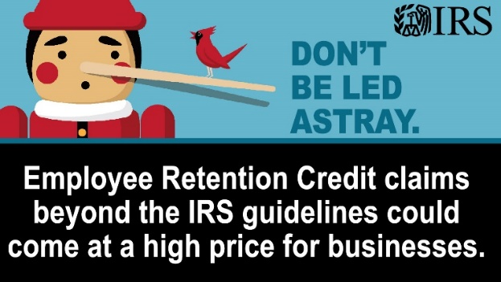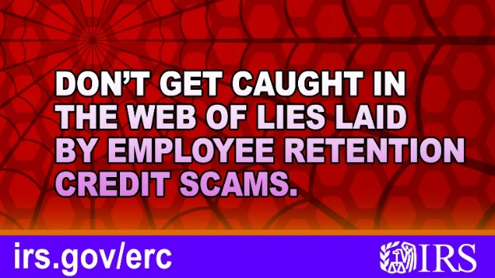
Spanish:
- Probablemente haya visto esos anuncios agresivos que alientan a las empresas y a otros a reclamar el Crédito de retención de empleados. No se deje engañar por las ofertas de ERC o ERTC más allá de las pautas del #IRS: www.irs.gov/erc
- El #IRS le advierte sobre estafas que engañan a personas no elegibles para reclamar el Crédito de retención de empleados. No lo reclame si no califica: www.irs.gov/erc
- Recordatorio: ¡Esa increíble oferta tributaria puede no ser cierto! El Crédito de retención de empleados ofrece a empleadores elegibles un crédito tributario contra ciertos impuestos sobre la nómina. Ofertas de ERC o ERTC más allá de pautas del IRS pueden costar. www.irs.gov/erc #IRS
- El Crédito de retención de empleados alentó a los empleadores a mantener a los empleados en la nómina a pesar de las dificultades económicas relacionadas con COVID. Tenga cuidado con las ofertas de ERC o ERTC más allá de las pautas del #IRS. Vea: www.irs.gov/erc
- El #IRS le insta a que no se deje engañar por las escandalosas ofertas de Crédito de retención de empleados que podrían tener un alto precio. Conozca el ERC o el ERTC antes de presentar un reclamo: www.irs.gov/erc
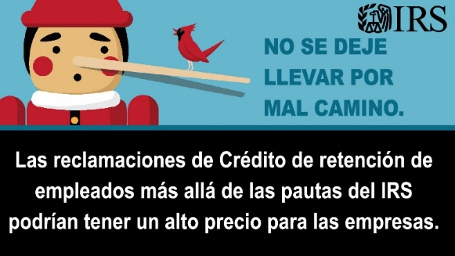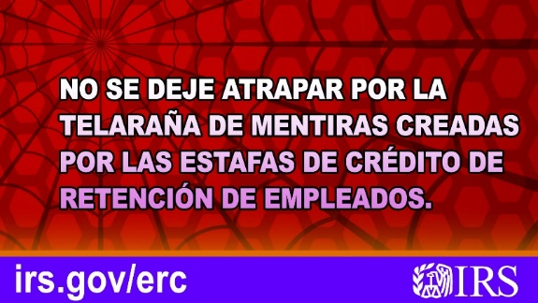
Employee Retention Credit fake claims:

English:
- The Employee Retention Credit encouraged employers to keep employees on the payroll despite COVID-related economic hardships. Beware of ERC offers beyond #IRS guidelines, as they could come at a high price. http://ow.ly/JHTA50Ox0hx
- Those eligible for the Employee Retention Credit are businesses and tax-exempt organizations that had a significant decline in gross receipts due to COVID. Don’t fall for ERC offers beyond the #IRS guidelines – they could cost you a high price. http://ow.ly/JHTA50Ox0hx


Spanish:
- El Crédito de retención de empleados alentó a los empleadores a mantener a los empleados en la nómina a pesar de las dificultades económicas relacionadas con COVID. Tenga cuidado con las ofertas de ERC más allá de las pautas del #IRS. Visite: http://ow.ly/JHTA50Ox0hx
- Los que son elegibles para el Crédito de retención de empleados son negocios y organizaciones exentas de impuestos que tuvieron una disminución significativa en los ingresos brutos debido a COVID. No se deje engañar por las ofertas falsas de ERC. http://ow.ly/JHTA50Ox0hx #IRS



Dirty Dozen – Employee Retention Credit scams:

- English – #IRS and #TaxPros continue to see the aggressive promotion of Employee Retention Credit schemes. Don’t be taken in by this Dirty Dozen scam: http://ow.ly/PYoR50NmUbN #TaxSecurity
- Spanish – #IRS y #TaxPros continúan mirando la promoción agresiva de esquemas de Crédito de retención de empleados. No se deje engañar por esta estafa de la Docena Sucia: http://ow.ly/fxWw50NFwk9 #TaxSecurity
- Chinese – #美国国税局 和 #税务专业人士 持续观察到大肆推广员工留任税收抵免的骗局。不要被卷入“肮脏十二条骗术”中的这类骗局：http://ow.ly/QGwX50NoZGi #税务安全
- Korean – #IRS와 #세무전문가들은 지속적으로 직원 유지 세액공제 수법에 대한 선전을 봅니다. 이 더티더즌 사기에 당하지 마십시오: http://ow.ly/QGwX50NoZGi (영어) #세금보안
- Russian – #IRS и #TaxPros продолжают сталкиваться с агрессивным продвижением кредитных схем удержания сотрудников. Не дайте себя обмануть этой аферой в стиле «Грязная дюжина»: http://ow.ly/PYoR50NmUbN (Английский) #TaxSecurity
- Vietnamese – #IRS và #TaxPros tiếp tục thấy các mưu đồ Tín Thuế Giữ Chân Nhân Viên được quảng cáo rầm rộ. Đừng để bị lừa bởi trò lừa đảo Dirty Dozen này: http://ow.ly/PYoR50NmUbN (tiếng Anh) #TaxSecurity
- Haitian Creole – #IRS ak #TaxPros kontinye ap wè pwomosyon agresif pou plan Kredi Retansyon Anplwaye yo. Pa kite yo twonpe w nan anak Dirty Dozen sa a: http://ow.ly/PYoR50NmUbN (an anglè) #TaxSecurity

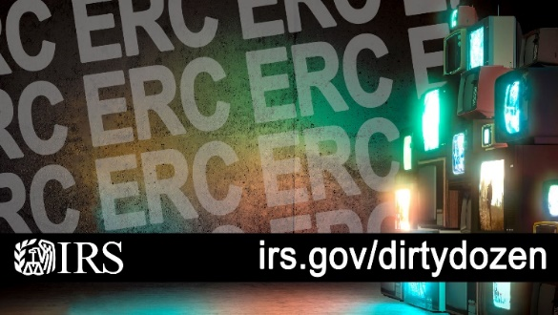

You can find more IRS social media content on these platforms:
- Instagram: Access IRSNews at Instagram.com/irsnews or the Instagram app.
- YouTube: Find video tips in English, Spanish and American Sign Language.
- Twitter: Follow @IRSsmallbiz information for small businesses, @IRSnews for tax announcements, @IRStaxpros tweets news for tax professionals, @IRSenEspanol for information in Spanish, and @IRStaxsecurity for posts on scam alerts.
- Facebook: Get news and information for taxpayers and tax return preparers; also in Spanish.
- LinkedIn: Find agency updates and job opportunities.
e-News subscriptions: The IRS offers several e-News subscriptions on a variety of tax topics. Subscribe to receive emails on topics of importance to small businesses, payroll professionals and tax professionals:
- IRS Outreach Connection
- e-News for Small Businesses
- e-News for Payroll Professionals
- e-News for Tax Professionals

